**IS203-G6T3 Use Case Diagram**

**Version 1.3**

**Last Date Modified: 18 September 2016**

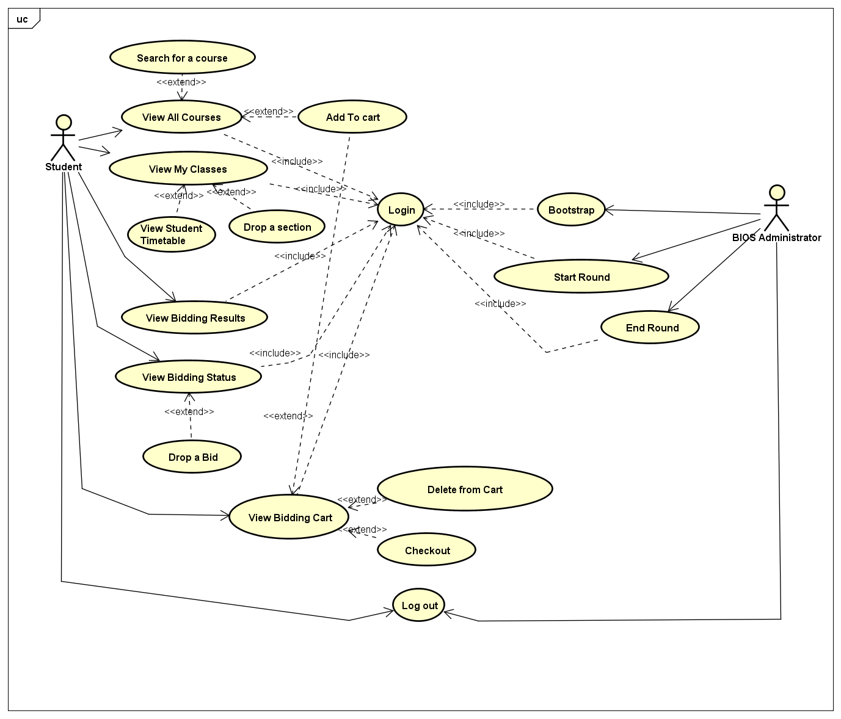

**Bootstrap**: Insert data into the database. It will conduct validations and return the correct number of entries inserted, as well as the number of rows with errors

**Start Round / End round**: Admin feature. This feature allows admin to start and stop a round and trigger the system to perform round clearing logic to insert successful bids into database and vice versa.

**Login**: Administrator and students are required to log in to the system to continue accessing other functions

**Log Out**: Admin and student can terminate their session and exit the system.

**Search for a course**: student is allowed to search for a course via Course code or course title and filter the results into a smaller list.

**View All courses**: student can view all courses to bid for in current round. Round 1 sees pre filtering to only allow student to see and bid for own school courses only

**Add to cart**: Allows student to add bid for a particular section to shopping cart for review before checking out as a bid.

**View My Classes**: Student can view all enrolled sections for the upcoming semester after the round is closed.

**View Student timetable**: Student can view all enrolled courses schedules as part of a timetable format to allow easier reference.

**Drop a section**: Student can drop a particular section and be refunded full amount to re bid for another section of another module

**View Bidding results**: Student can view the results of a bidding round and all his/her bids when the round is closed, and even when round 2 is started in the homepage and in the view my classes page

**View Bidding status**: Student can view the bid status of all the bids placed.

**Drop a bid**: Student can drop his/her bids after placing his/her bids.

**View Bidding cart**: Allows student to see and review his bids before checkout collectively.

**Delete from Cart**: allows student to drop a particular shopping cart item to add more items into their cart for checkout

**Checkout**: allows student to check-out all the bids collectively for easier reference and review.